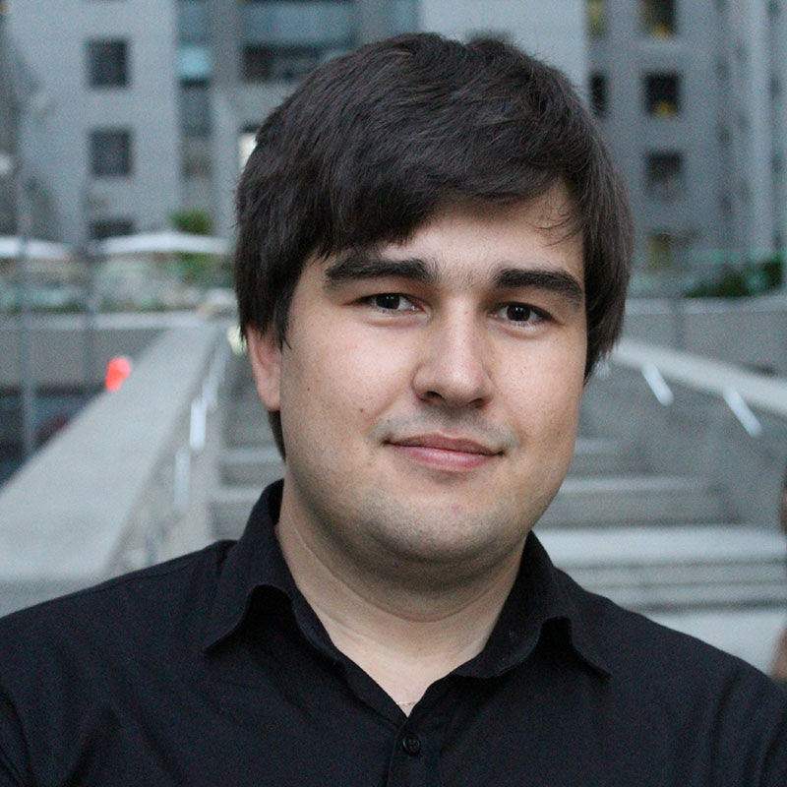
Titorenko Oleksandr
Address: Kiev, Ukraine
Telephone: +380636284343
Emal: titorens@gmail.com
Skype: titorenko.oleksandr
Site: titorenko.com.ua

EMPLOYMENT HISTORY

Senior web developer

21Pink

October 2016 – June 2016 (9 months)

PHP 7, RabbitMQ, MongoDB, Redis, Ratchet, AWS

Senior web developer

Jobmap(https://jobmap.co/)

September 2016 – …

PHP 7, Angular 2, Laravel, Lumen, Redis

PHP middle developer

JohnLarckin

February 2015 – September 2015 (8 months)

My work:
http://ictweek.uz/ (API + Web Page + admin panel)
(PHP5.5, Backbone Js, CSS5, Lumen, require js, swipe, bootstrap)

Mprrow/ Node JS(websocket.io + mongoose) + mocha (BDD Testing) + migration + express

PHP middle developer

BigDig (http://bigdig.com.ua/)

May 2014 – January 2015 (9 months)

My work:

http://a-chat.bigdig.com.ua/ Front-End und Back-End (PHP5.5 + MongoDb + Backbone Js + CSS5 + Yii + Node JS(websocket.io + mongoose) + mobile API)

Freelancer

oDesk

April 2014 – July 2014 (4 months)

My work:
http://wikiscrapper.splesk.com/ (Codeigniter + MySQL)
Support project:
http://www.voucherconnect.com/ (Codeigniter + MySQL)

Developer PHP

T4web(http://t4web.com.ua/)

July 2013 - March 2014 (9 months)

My work:
http://ukravtolombard.com.ua/ (Zend + MySQL)
Support project:
http://smak.ua/ (PHP + Zend + PostgreSQL)
http://avtoradio.ua/ (Zend + MySQL + Backbone Js )
http://navsegda.com/ (Zend + Xaraya + Redis + MySQL)
http://guerlain.ua/ (Zend + MySQL + Backbone Js)
http://www.sirotstvy.net/ (Zend + PHP + PostgreSQL)
http://advermap.com.ua/ (Zend2 + Backbone Js + MySQL + Rescue js)

Developer PHP

VeGo
November 2011 - April 2013 (1 year 6 months)

My work:
http://pride-production.com/ ( framework Kohana, PHP+MySQL+CSS+ Javascript+Jquery ); http://webd.org.ua/( framework Kohana, PHP+MySQL+CSS+Javascript+Jquery+bootstrap)

Professional Skills:
- Programming Languages/Technologies
  - PHP 5, PHP 7
  - JavaScript
  - AJAX
  - XML / XHTML / HTML
  - ORM
  - CSS
  - MVC (Model View Controller)
  - GIT
- Frameworks
  - Zend
  - Kohana
  - Yii
  - Codeigniter
  - Laravel, Lumen
- Template Engines (Smarty)
- RabbitMQ
- JavaScript Libraries / Frameworks
  - jQuery
  - Node.js
  - Backbone
  - Angular 2
- Databases
  - MySQL
  - PostgreSQL
  - MongoDB
  - Redis
- Standards
  - HTML 5, HTML 4.01, XHTML 1.0/1.1
  - CSS1, CSS2, CSS3
  - DOM
- Protocols
  - HTTP
  - CGI
  - REST
- Application Environments
  - Apache
  - PHP
  - ASP
- Operation systems/platforms
  - Unix/Linux (Debian, Ubuntu)
  - Windows 95/98/2000/XP/2003/Vista/2008/Windows 7/Windows 8
- Administration
  - Ubuntu
  - EC2
EDUCATION
KNSL № 145 Kiev Ukraine
High School Diplom, May 2009

National Technical University of Ukraine 'Kyiv Polytechnic Institute'
Instruments and Systems of Non-Destructive Testing
Personality:
- Sociable, Intelligent, Responsible.

